Final Assessment
Level: Bachelor Year: 2011
Programme: BE (III Sem) Full Marks: 100
Course: Network Theory Time: 3 hrs.

- a) The switch K in the network of the figure is closed at t=0 connecting the battery to an un-energized network. Determine i, 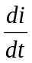, 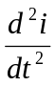 at t=0. [7]
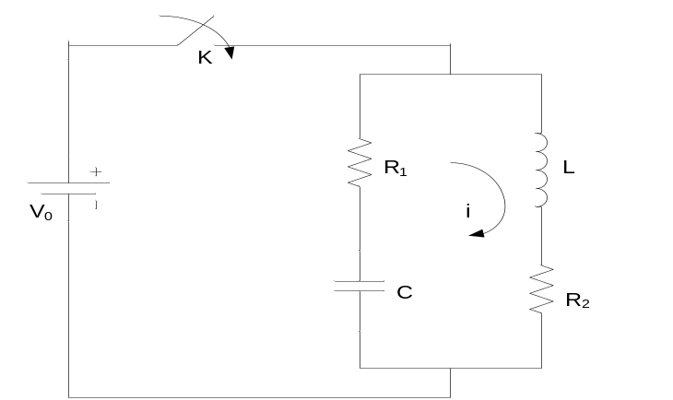
(b) In the network shown, the switch K is moved from position a to position b at t=0, steady state condition having reached previously. Solve for the current i(t) using the classical approach. [8] 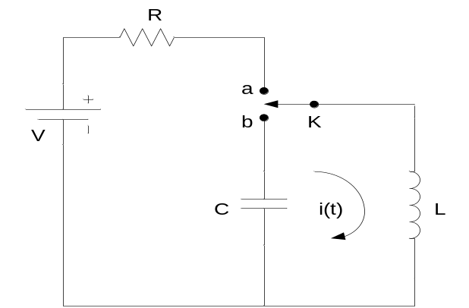

- a) A sinusoidal voltage 15sin (8t-30⁰) is applied at time t=0 to a series R-L circuit comprising of resistor R=4 Ω and inductor L=1H. Using classical approach, find current i(t). Assume zero current through inductor before application of voltage. [8]

b) Find the expression of discharging voltage of the capacitor at t=0 when switch is closed at t=0 in the following network. [7]
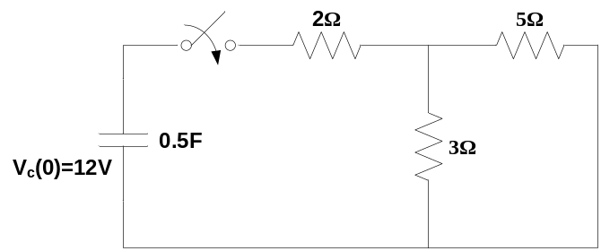

- a) Solve the following second order differential equation using Laplace transformation method: 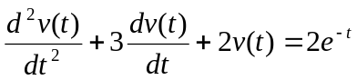 [8] Given initial conditions are v (0) = 2 and 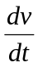(0) =0.
b) For the series circuit having R= 1Ω and C= 0.5F with no initial voltage across the capacitor, a voltage V = 10e^{-t} volts is applied at t=0. Find the expression for the resulting current in the circuit for t>0. Use Laplace transform. [7]
4. a) Check the stability of the following system and hence determine the number of roots with (i) positive real parts (ii) negative real parts and (iii) zero real parts. Apply Routh-Hurwitz criteria. N(s) = s⁴+2s³+2s²+6s+10 = 0 [8]
b) The transfer function of a network is given by:
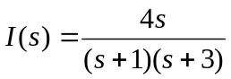. Plot the poles and zeroes in s-plane and obtain i(t). [7]
5. a) Determine the Fourier coefficients of the following waveform. [7]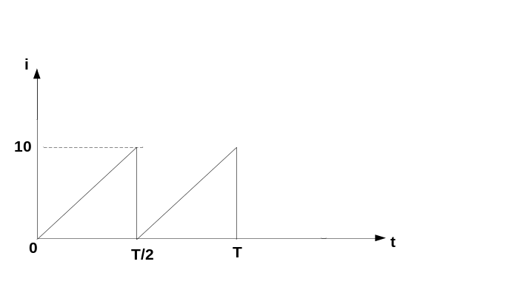

b) Draw the asymptotic magnitude plot for the transfer function. [8]
G(s) = 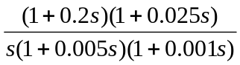
6. a) Obtain the open circuit parameters for the network shown below. [8]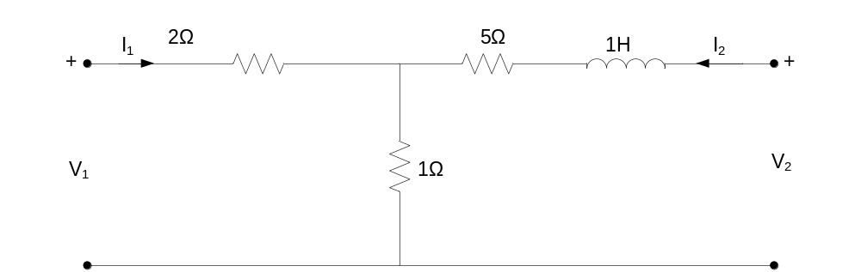
b) Find hybrid parameter for the two port network below. [7] 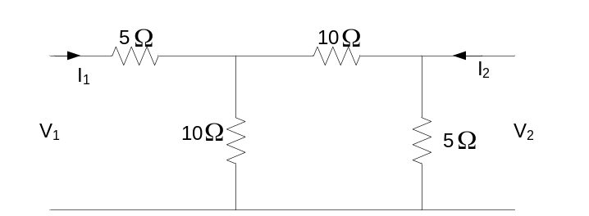
7. Write short notes on any two of the following: [10]
a) Initial and Final Value theorem.
b) Poles and Zeroes of network function
c)Time constant of RC circuit

